**PHOTOCGRAPHIC ESSAY**

**The Silent Crisis: Climate Change in Rural African Communities**

**1. Introduction: Setting the Scene**

**Text:**  
"In the heart of Africa, rural communities are bearing the brunt of climate change. As temperatures rise and weather patterns become increasingly erratic, these communities face challenges that threaten their way of life."

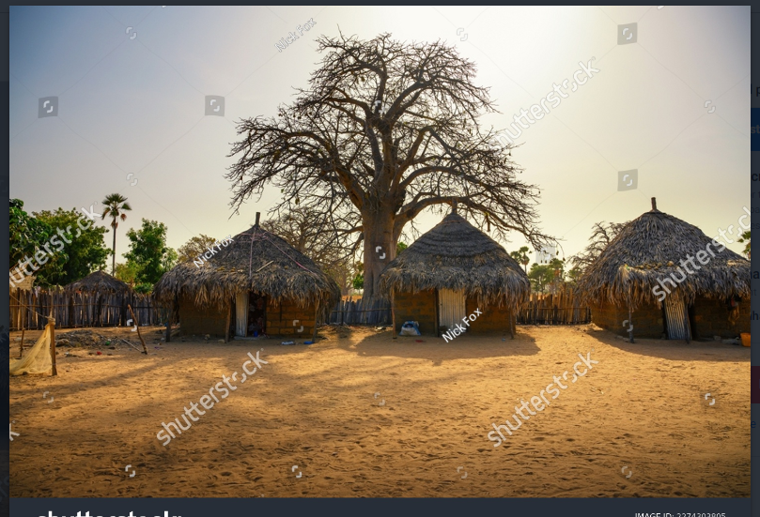

**2. Drought and Water Scarcity**

**Text:**  
"Droughts have become more frequent and severe, leading to water scarcity. Women and children, who are often responsible for fetching water, are spending hours each day walking long distances to find sources of water."

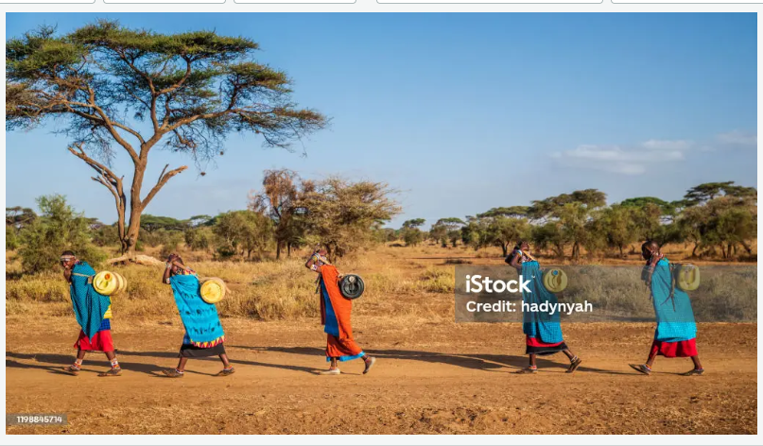

**3. Impact on Agriculture**

**Text:**  
"Agriculture, the backbone of rural economies, is severely impacted. Erratic rainfall and prolonged dry spells have reduced crop yields, making food insecurity a growing concern."

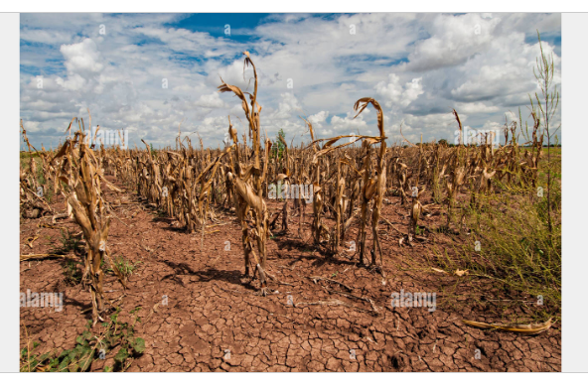

**4. Livestock Losses**

**Text:**  
"Livestock, crucial for livelihoods and food security, are also suffering. Increased temperatures and decreased water availability have led to higher mortality rates among cattle and other livestock."

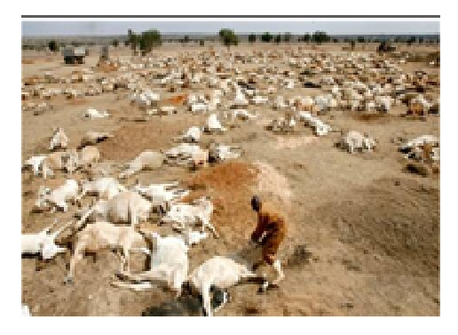

**5. Health Implications**

**Text:**  
"The changing climate is exacerbating health problems. Malnutrition, waterborne diseases, and heat-related illnesses are on the rise, straining already limited healthcare resources."

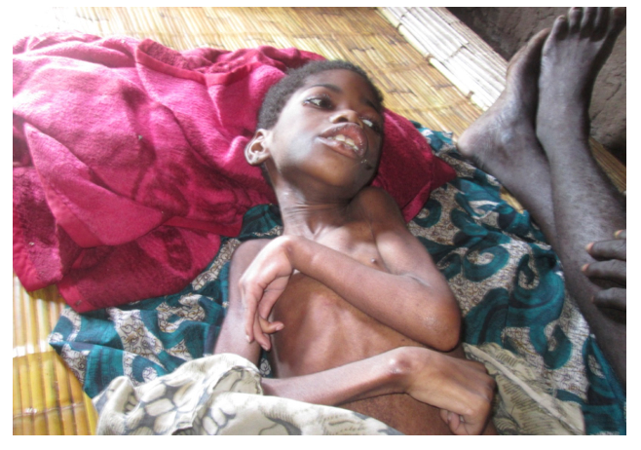

**6. Community Resilience and Adaptation**

**Text:**  
"Despite these challenges, communities are finding ways to adapt. Innovative farming techniques, rainwater harvesting, and community-based conservation efforts are helping to build resilience."

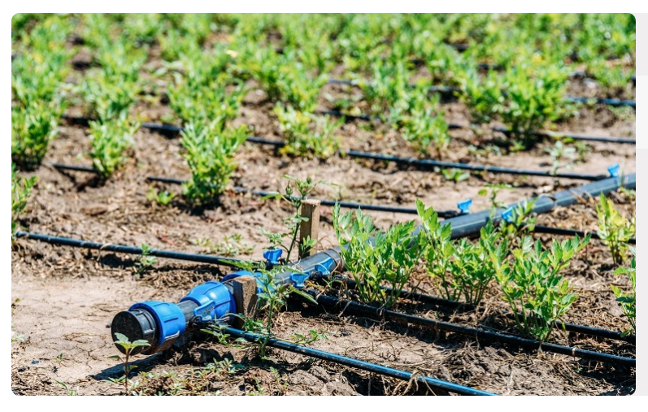

**7. The Role of Youth and Education**

**Text:**  
"Younger generations are increasingly aware of the issues and are taking action. Education and community mobilization are key to empowering the youth to drive sustainable solutions."

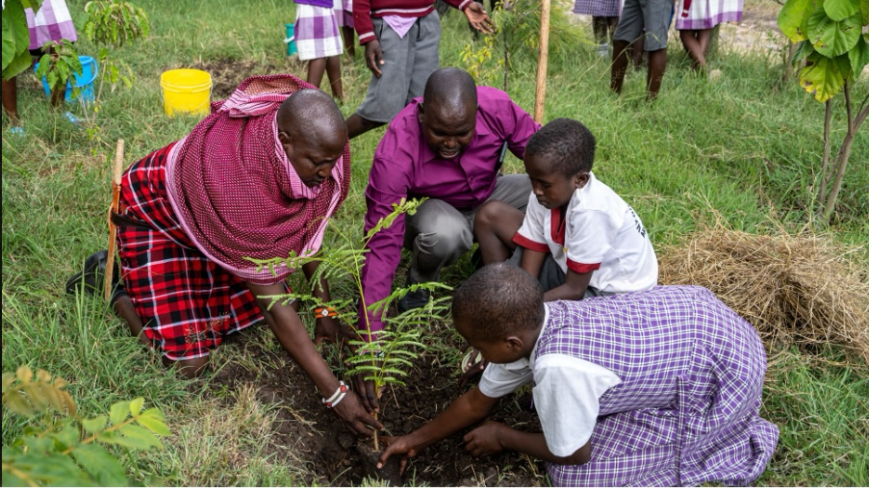

**8. Call to Action: Global and Local Solutions**

**Text:**  
"Addressing climate change requires concerted efforts at both global and local levels. Supporting sustainable practices, investing in climate-resilient infrastructure, and fostering international cooperation are crucial steps toward a sustainable future."

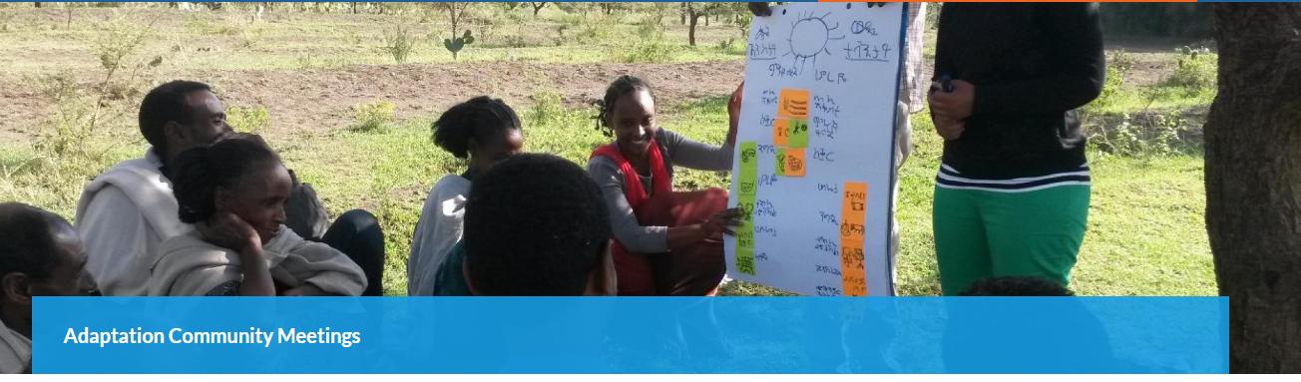

**9. Conclusion: Hope Amidst Adversity**

**Text:**  
"While the challenges are daunting, the resilience and innovation of rural African communities shine through. With the right support and solutions, these communities can overcome the silent crisis of climate change."

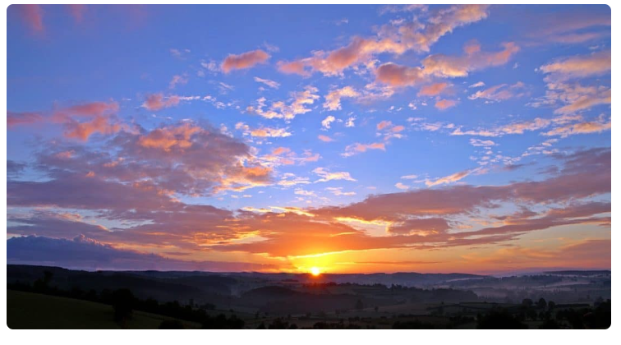

**Narrative of the photographic essay**

**The Silent Crisis: Climate Change in Rural African Communities**

In the heart of Africa, where the land is as ancient as time itself, rural communities are grappling with a crisis that silently erodes their way of life. Climate change, with its unpredictable patterns and escalating temperatures, is reshaping landscapes and livelihoods. This narrative explores the profound impact of these changes, the resilience of the people, and the silent battle they face each day.

**Drought and Water Scarcity**

In the sweltering heat of a parched landscape, a woman carries a large, heavy water container on her head. Her journey through the cracked earth is a daily ritual, a testament to the water scarcity that has become a relentless adversary. The once fertile fields now lay barren, a stark reminder of the changing climate. Droughts, once rare, have become a regular torment, forcing communities to trek miles in search of water. The weight of the water container is not just physical but a burden of survival, echoing the silent cries of a land that is losing its life-giving essence.

**Impact on Agriculture**

The backbone of rural economies, agriculture, is facing unprecedented challenges. Fields that once thrived with lush crops now lie withered under the relentless sun. A farmer stands in his parched field, the dry earth beneath his feet a stark contrast to the verdant pastures of yesteryears. The erratic rainfall has reduced crop yields to a fraction of what they once were, pushing families to the brink of food insecurity. The struggle to harvest enough to feed their families is not just a battle against the elements but against time itself, as the land they depend on continues to wither away.

**Livestock Losses**

Livestock, the lifeblood of many rural households, are also bearing the brunt of the changing climate. Under the scorching sun, a herd of emaciated cattle roams the parched plains. The scarcity of water and the rise in temperatures have led to higher mortality rates among these animals, which are crucial for the livelihood and sustenance of the communities. The sight of these weakened animals, their once strong frames now frail, is a poignant symbol of the crisis. Each loss is not just a blow to the economy but to the very fabric of rural life.

**Health Implications**

The health implications of climate change are increasingly severe. Malnutrition, waterborne diseases, and heat-related illnesses are on the rise, overwhelming already limited healthcare resources. In a modest health clinic, children with visible signs of malnutrition lie on makeshift beds, their frail bodies a stark contrast to the vibrant life they should embody. The clinic, a small haven in a vast sea of challenges, struggles to cope with the rising tide of health issues. The changing climate has not only altered the landscape but has also undermined the very health of the people who call this land home.

**Community Resilience and Adaptation**

Amidst the challenges, there is a glimmer of hope in the innovative spirit of the communities. Farmers are turning to drip irrigation, a technology that saves water and ensures crops receive the nourishment they need. Rainwater harvesting systems are becoming a common sight, transforming the way communities manage their most precious resource. These efforts, often spearheaded by the local people themselves, are a testament to their resilience and ingenuity. The spirit of adaptation is palpable, as communities come together, pooling their resources and knowledge to rebuild what the climate has taken away.

**The Role of Youth and Education**

The youth of these communities are not just witnesses to the crisis but active participants in the fight against it. In schools and community centers, young people are engaged in tree-planting activities and environmental education programs. Their faces, filled with determination and hope, reflect a generation that is increasingly aware of the challenges ahead. These young activists are not just planting trees; they are sowing the seeds of a sustainable future, inspired by the belief that they can make a difference. Their energy and resolve are crucial in turning the tide against the silent crisis.

**Call to Action: Global and Local Solutions**

Addressing climate change requires a concerted effort, bridging global support with local action. Communities are calling for sustainable practices, resilient infrastructure, and stronger international cooperation. In a local community meeting, leaders and international representatives gather, discussing strategies to combat the climate crisis. The air is filled with the sound of voices united in purpose, as plans and projects take shape. This collaboration is a beacon of hope, showing that when local wisdom meets global support, solutions can be forged.

**Conclusion: Hope Amidst Adversity**

The journey through the challenges posed by climate change is daunting, yet the resilience and innovation of these rural communities shine through. From the arid fields to the struggling livestock, from the health clinics to the young activists, the spirit of hope and determination is undeniable. As the sun rises over a recovering landscape, it symbolizes the promise of renewal and the unwavering resolve of a people who refuse to be defeated by the silent crisis. With the right support and solutions, these communities will not only survive but thrive, turning adversity into a testament of human spirit and resilience.

In the heart of Africa, the silent crisis of climate change continues to unfold. But amidst the challenges, there is a story of hope, resilience, and the indomitable will of communities determined to overcome the odds. This is their journey, a narrative of survival, adaptation, and the unyielding spirit of humanity.